**DFD Points**

Please remember the following pointers when drawing a DFD diagram.

In DFD level 0, there is just one process (e.g. flex) and entities that are interacting with it. There is no data store or DB.

The data flow arrows are labeled. You can have one arrow with one label (e.g. student to flex system has two arrows, labeled differently – labeled with what a student can do with the system) and Faculty has one arrow with multiple labels.

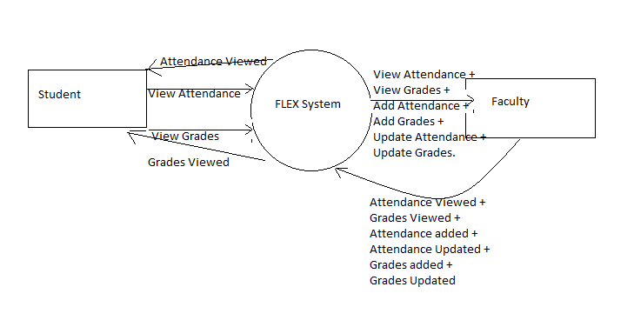

In DFD level 1 (not given here), you will have to divide the process

Processes are all the different actions that are occurring within the system. So from above example, we will have two processes interacting with student and six processes interacting with the Faculty.

From a paragraph, all verbs are possible candidates to be a process.

Also, please note the following:

1. An Entity cannot interact with the Data store directly. There will always be at least one process in between them. In other words, there will be no arrow going from an entity (say student) to Attendance DB directly. It will only go through some process.
2. Processes can interact with other processes.

From the above diagram, there will be a total of 6 processes which are listed as following:

1. View grades -- both the student and faculty can interact with this process
2. View Attendance -- both the student and faculty can interact with this process
3. Add grade -- only Faculty
4. Add Attendance -- only Faculty
5. Update grade -- only Faculty
6. Update attendance -- only Faculty